**COHORT 2.0**

**TYPESCRIPT**

Compiler and interpretted languages

Strongly types and loosely typed languages

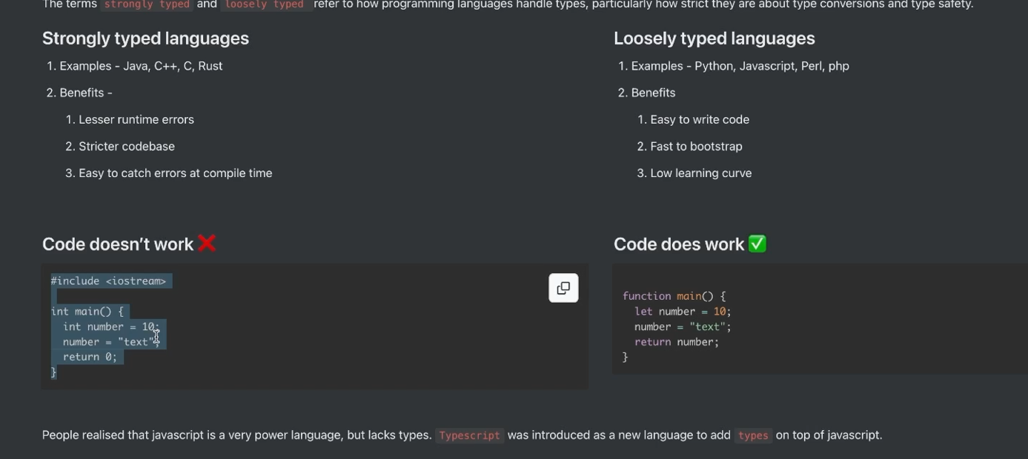

What is typescript -developed by microsoft - superset of javascript - strict syntactical superset and adds optional static typing to the languaege- for eg int x, we have ourselves told the compiler that x is gonna be intger value - typescript provide type to javascript

How does typesript code run? We never run/execute typescript file

TS code never runs in browser -it never runs

Js is runtime langugage ( that runs in our browser/nodejs runtime)

Typscript compiles/transpiled to js

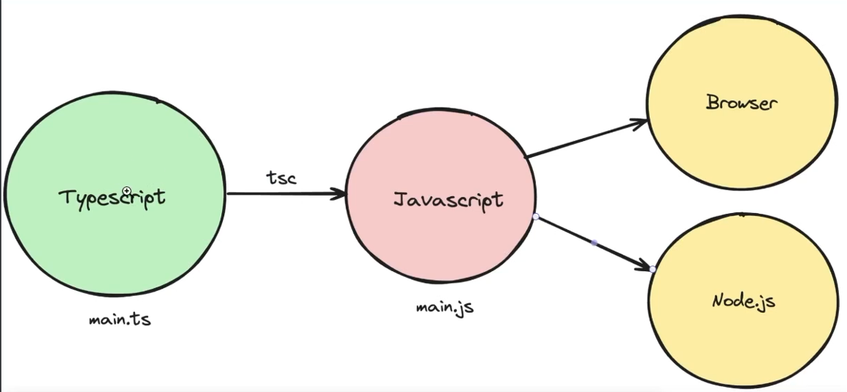

Typescript compiler

Tsc is typescript compiler -esbuild and swc transpiler or compiler which convert typescript to javascript

When we execute command npx tsc --init

It will create a tsconfig file in which there are bunch of variables which u can tweak to change the way how u want coversion

We create a file called x.ts and if u want it to covnert it to js file we use tsc -b command , if we want to run it we use node a.js not a.ts file

Other types - number, string , boolean, null, undefined

Type inference -if a is number and b is a number and we return a+b it will return a number it infers it

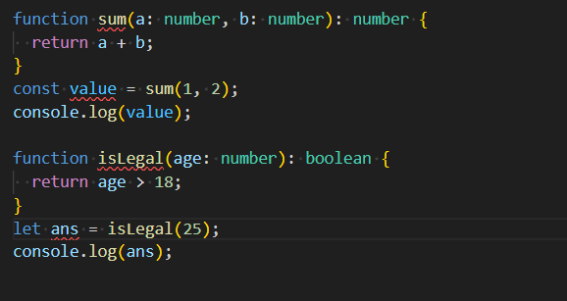

How to pass a function to another function which are also called callbacks

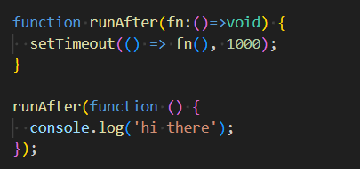

We never commit dist to github

rootDir:”./src”

outDir:”./dist”

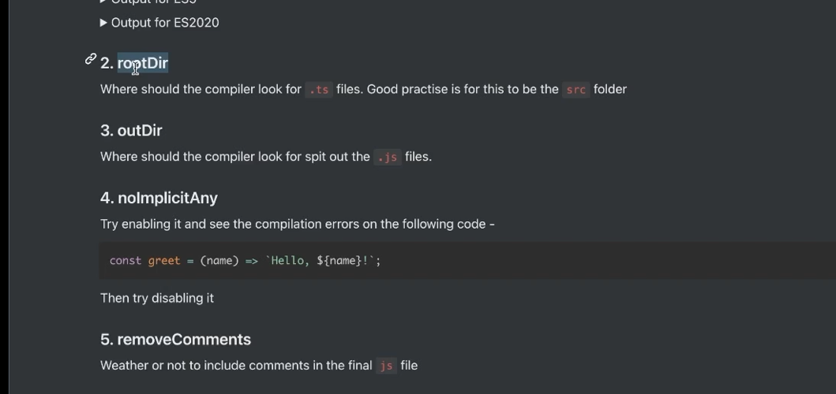

Interfaces

How can we assign types to objects:??

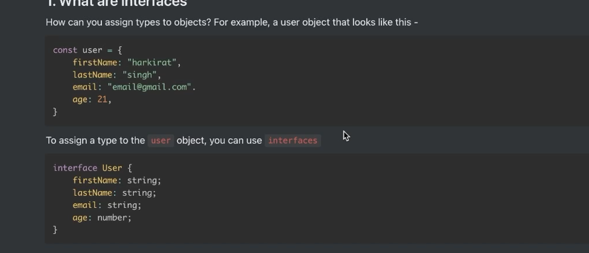

Type and Interface

Diiference kya hai fir?

Type cant be used to implement classes but we can use interfaces to implements classes

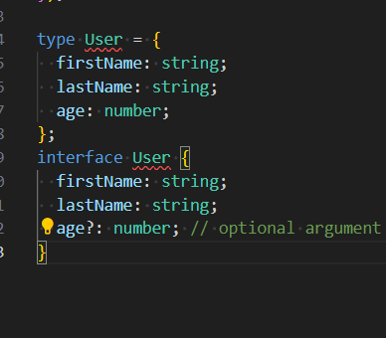

Then difference kya hai type aur interference me?

Type let u aggregate data using union and interesection too

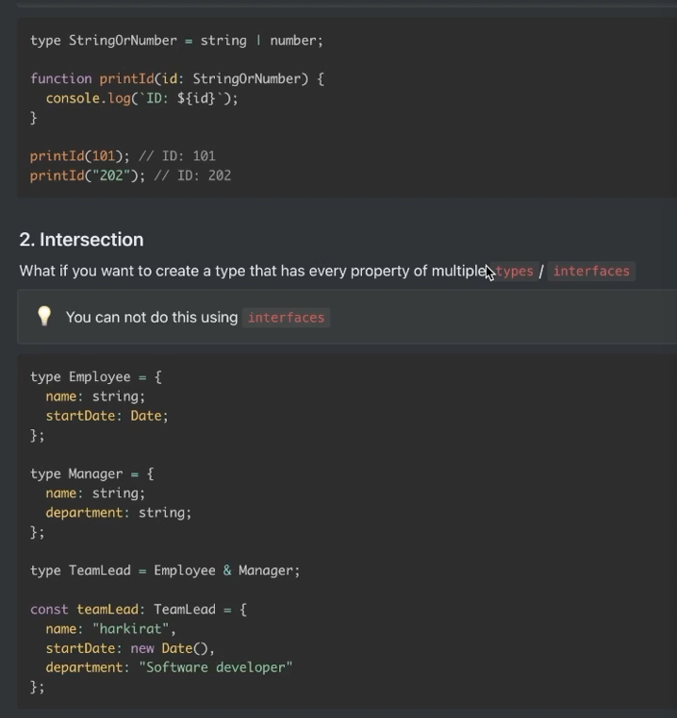

**Arrays in TS**

Add [] as type

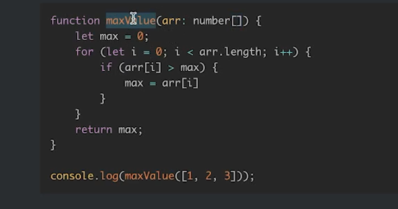

Array of user which is an interface or can be type

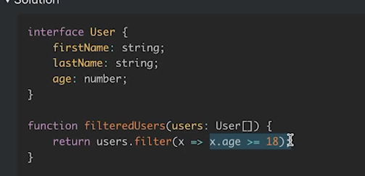

**2nd CLASSS**

**ENUM-** enumerations -define a set of named constants, it creates a human-readble way to represent a set of constant values, which might otherwise be represented as number or strings

Ways to give enums

Converted to js as hashmaps

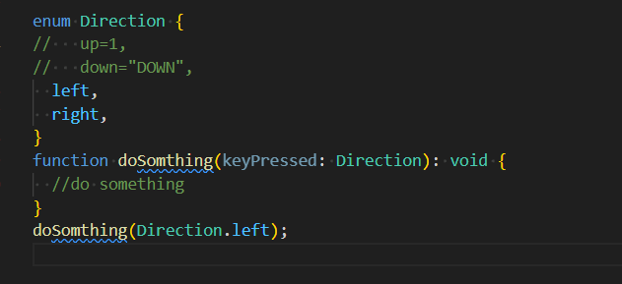

Use case in expres

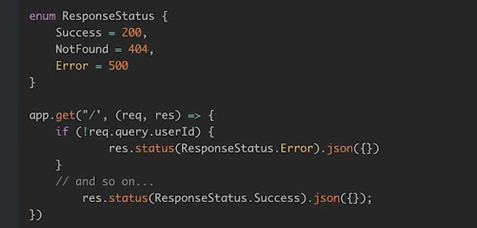

**Generics**

Language independent

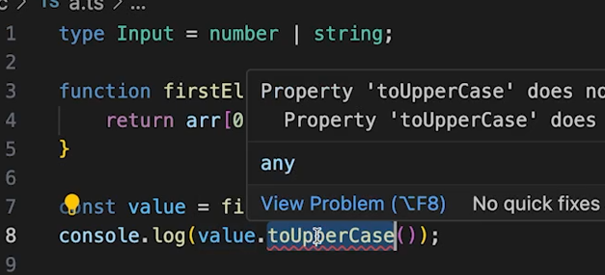

Problem is we cant use toUpperCase coz value can be either number or string

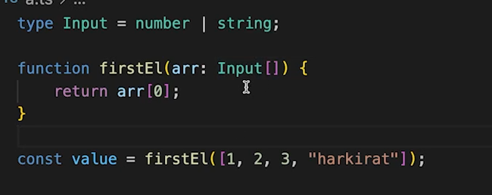

One can send a bag of both numbers and strings and typescript wont complain

Solution to these problems is GENERICS

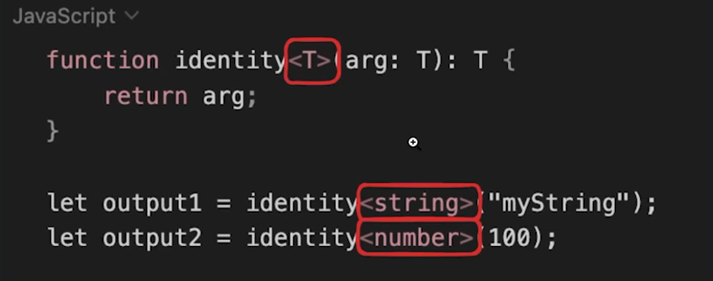

IMPORT EXPORT IN TS

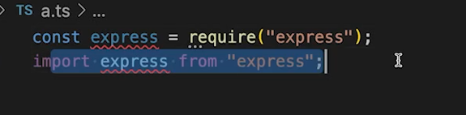

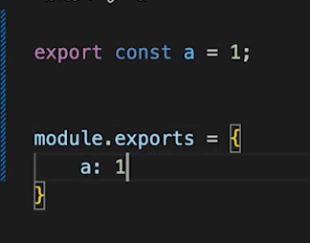

If we do default export then we don’t have to use{} while importing and if we are using normal export we have to use {} while importing stuff in other files

**SQL DATABASES [ POSTGRES]**

Db are of many types - sql and nosql

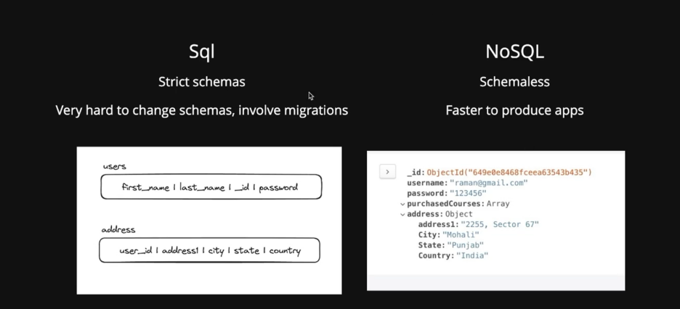

Sql - strict schemas- upfront pr btana pdta hai-tables -queries

Nosql -schemaless

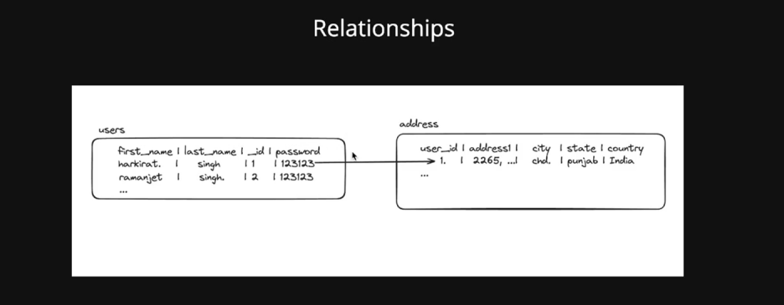

Normalize db -address will be another table - either put 10 fields in 1 table or normalize break down db into smaller tables which are related to each other

**Connecting to Postgres**

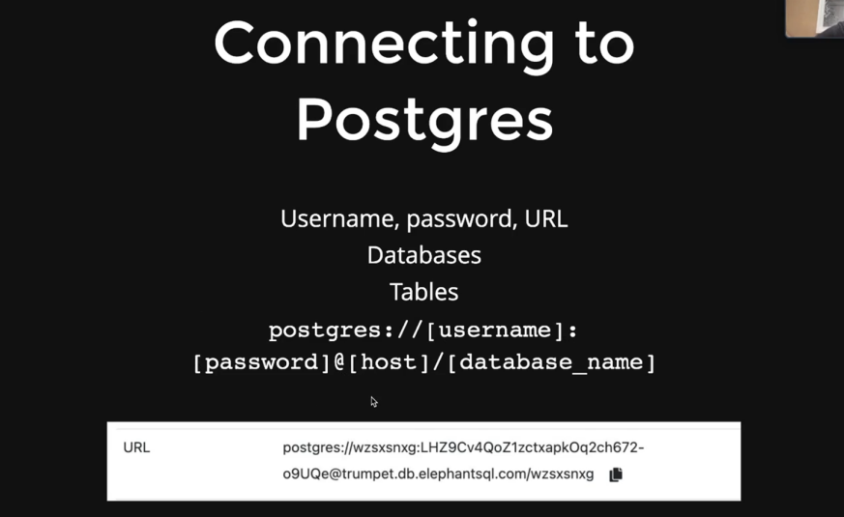

Purpose of db- querying on data

4 basic queries

Node js should be stateless( for eg userdata we store in file system)

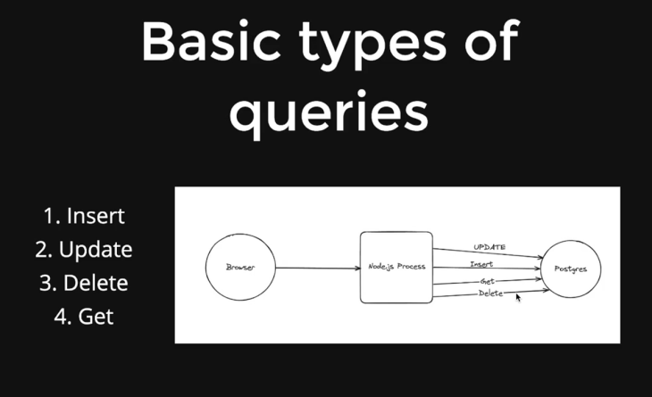

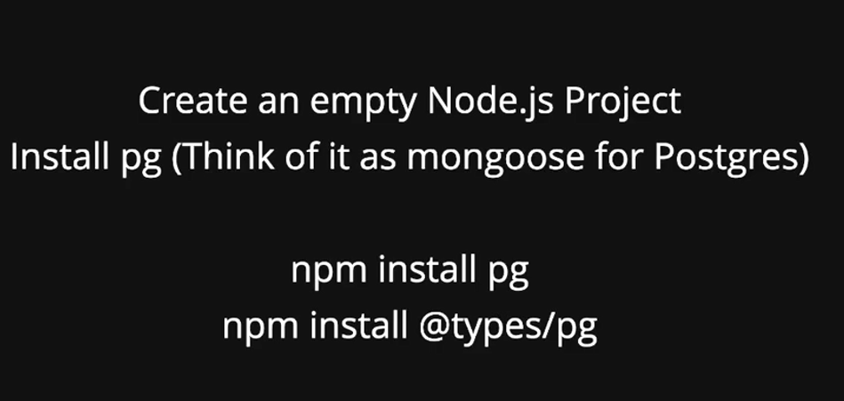

TODO

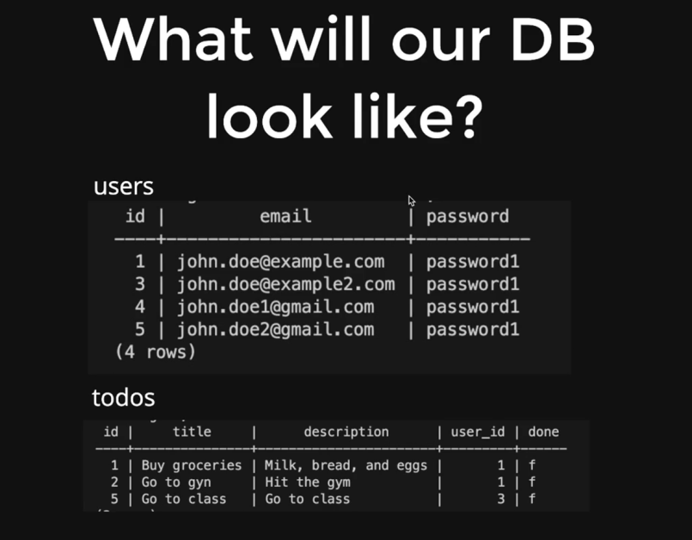

We haave to tell postgress how should table look like

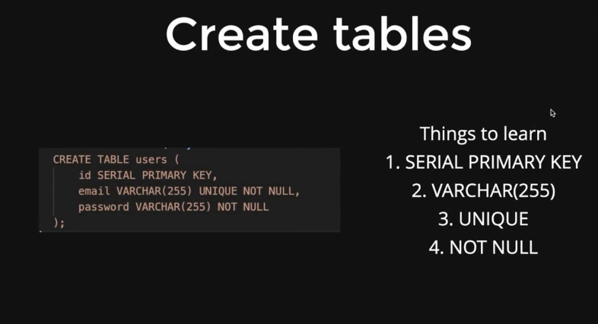

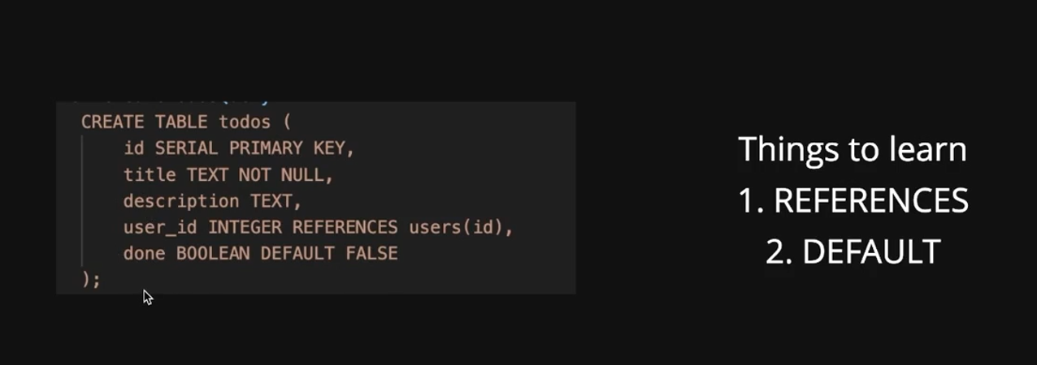

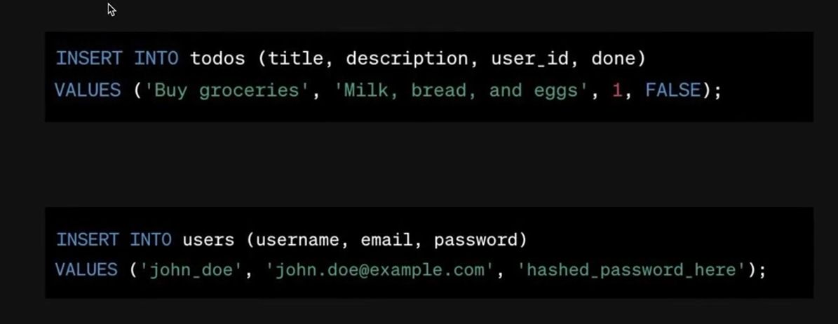

Why we do variable templates? Sql injection

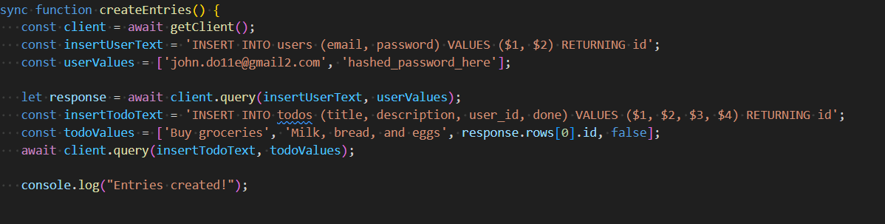

If user send harkirat singh; drop table users; it will go as sql query

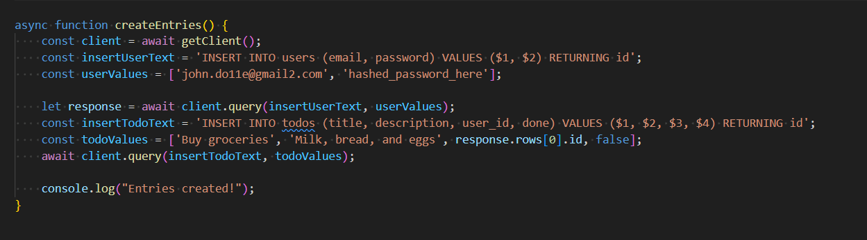

To get user

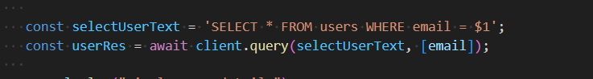

Update data



Delete data

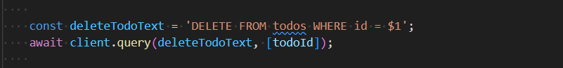

JOINS

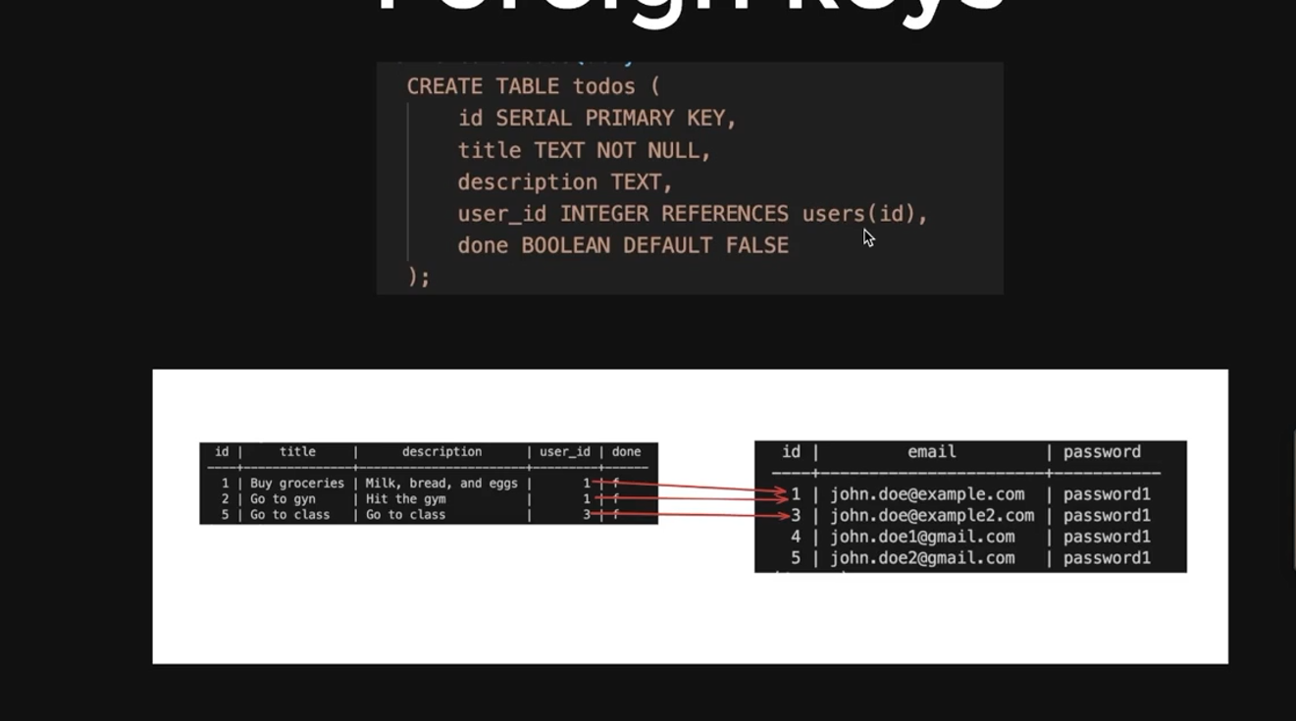

Any better way to do it?

Answer joins-query faster , decrease db calls

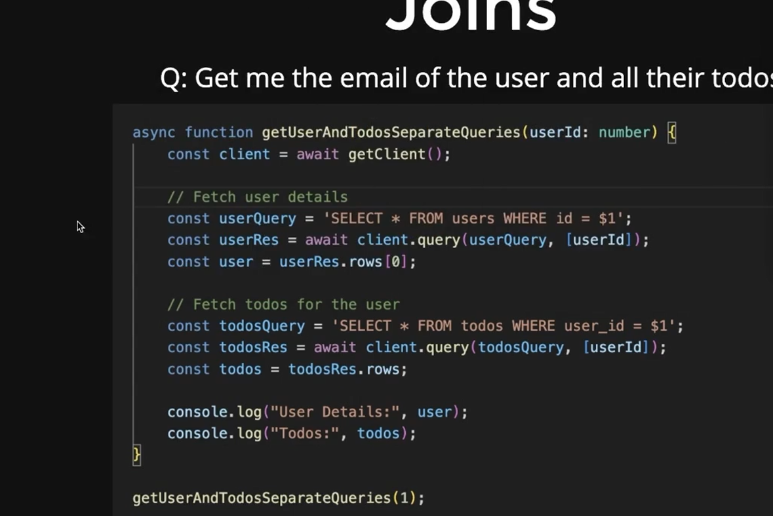

Solution

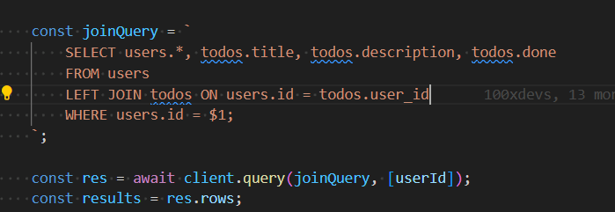

Types of joins

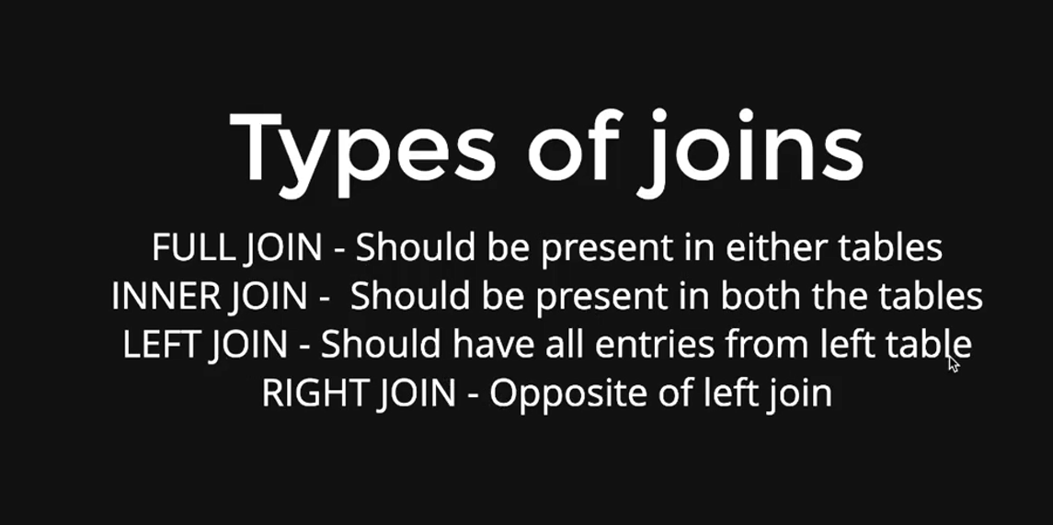

Agar user hai but no todos and we do left join- we get user info but null on todo

Default value-inner join

**PRISMA ORM**

Encapsulates functions and queries we used in SQL

Why we need ORMS?

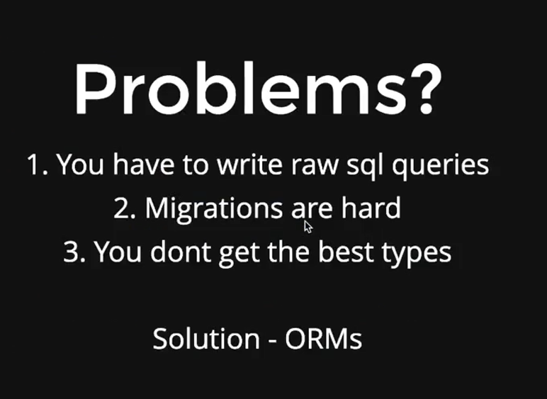

Types means when we import a model , we get a lot of functions while we were using mongoose but if we wont use it we don’t get enough types

Object relation model –it gives us easy function for data model , automated migrations , type safety and auto completion

Popular ORMS- prsima sequelize , mongoose etc

Prisma ORM consist of 3 parts

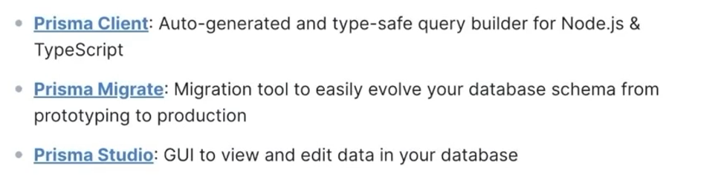

What do u mean by automated migrations??

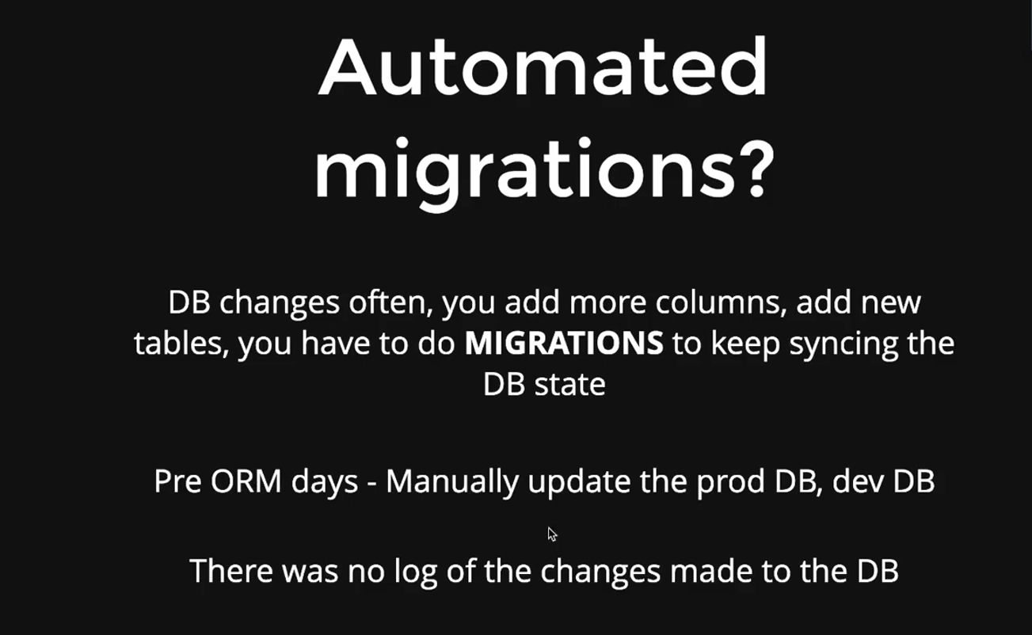

How to start?

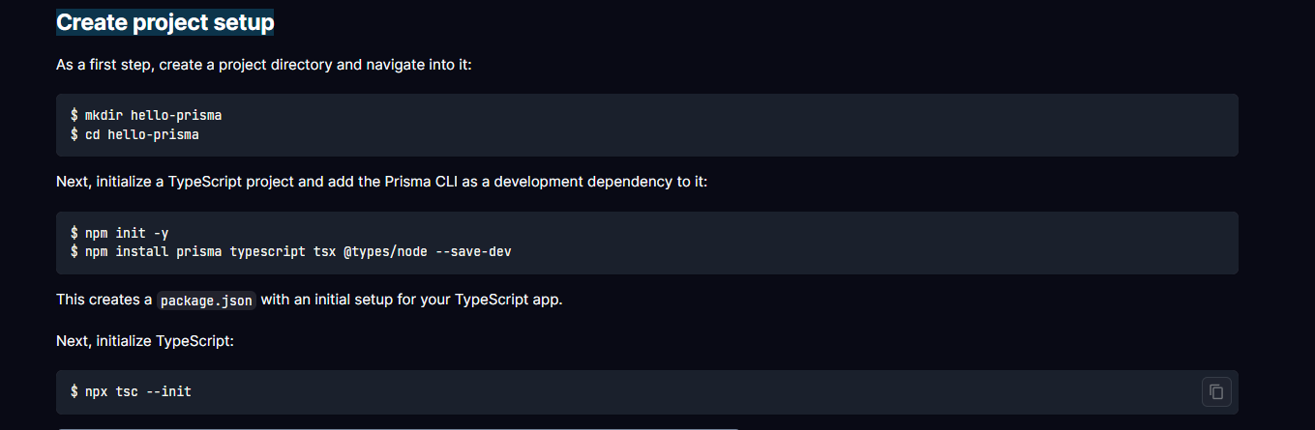

This is how we model in prisma and it convert them to raw sql

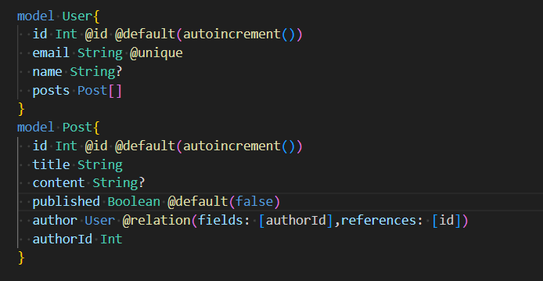

Now we have to run a migration to basically map our data model to database schema

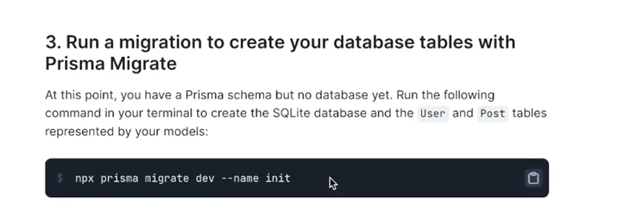

In future when we change our models we just have to add that particular name instead of init

Now we create user and create post

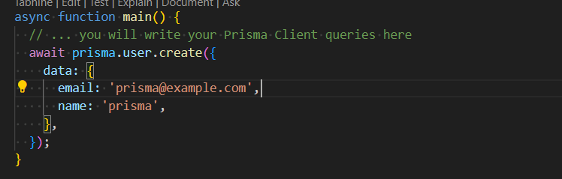

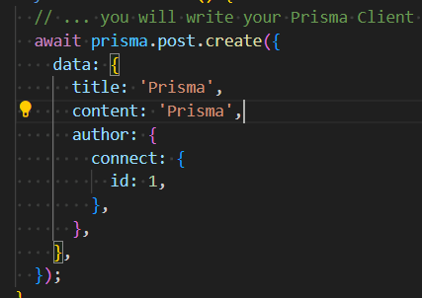

How to get data

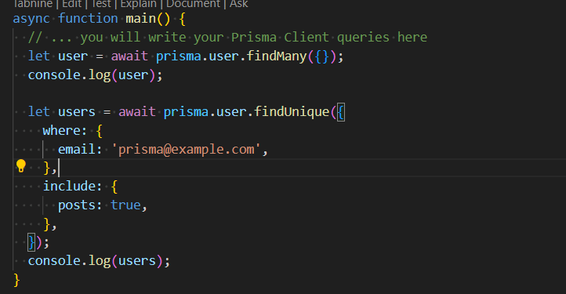

Update user

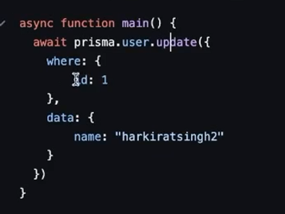

If we want to delete posts which are unpublished with user id 1

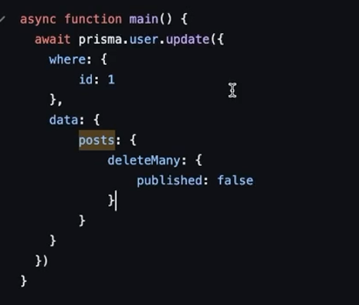

We can get deeper and deeper in foreign keys too

We can also do adnvce SQl query very easily using PRISMA ORM

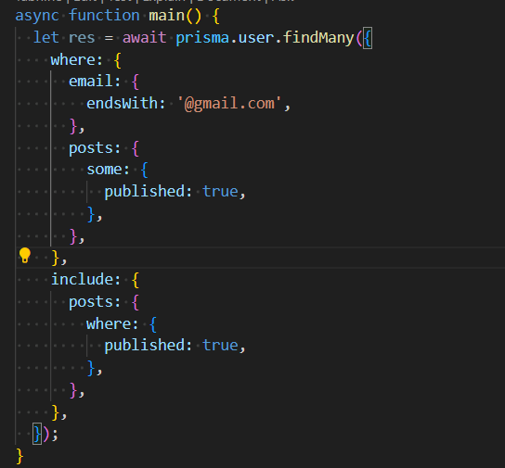

We are finding all the users whose email id ends with @gmail.com and which has some posts which are not published and along side the user info if we also want to see those posts we can do it using include we include all the posts which are published

How to do pagination in PRISMA ORM

